DBMS

Ex–5 Integrity Constraints Commands

Name:- K. DUSHYANT REDDY Reg No.:- RA1911033010029

Branch:- CSE-SE

AIM:

To implement commands like primary key, foreign key, check, unique and index.

COMMANDS:

1. PRIMARY KEY/UNIQUE – value which is unique for every record in the table.

Syntax-

CREATE TABLE <table-name> (<column name> <data type>(<size>) PRIMARY KEY, …);

CODE-

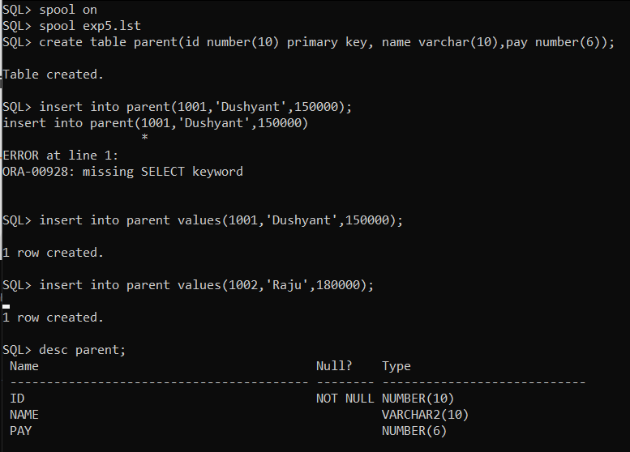

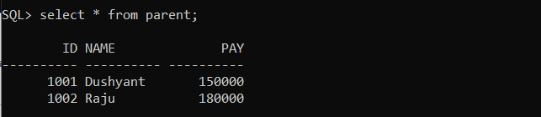

1. FOREIGN KEY – Used to relate to the primary key of another table.

Syntax-

CREATE TABLE <table-name2> (<column name> <data type>(<size>), … REFERENCES <table-name1> <column name);

CODE-

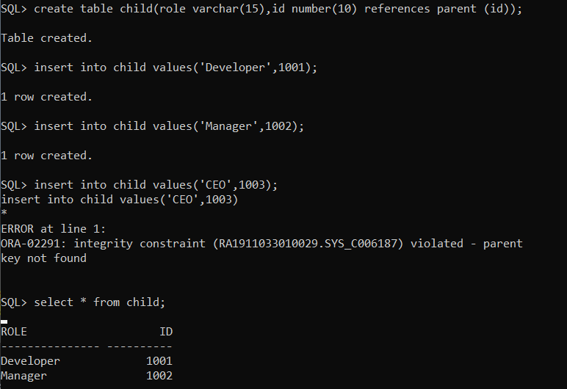

1. NOT NULL – Used to implement a column to NOT accept NULL values in the table.

Syntax-

CREATE TABLE <table-name> (<column name> <data type>(<size>) NOT NULL,… );

CODE-

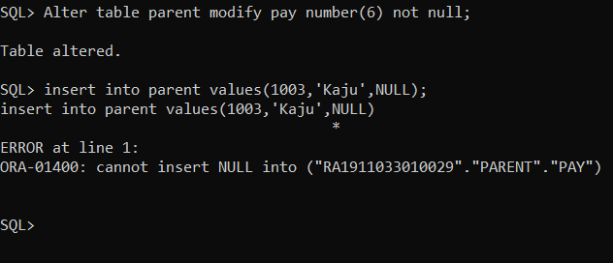

1. CHECK – Used to limit the value range that can be placed in a column in the table.

Syntax-

CREATE TABLE <table-name> (<column name> <data type>(<size>) CHECK (condition),… );

CODE-

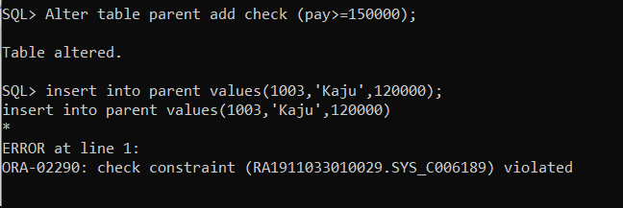

1. INDEX – Used to retrieve data from the database more quickly than otherwise.

Syntax-

CREATE INDEX <index name> ON <table name> (<column name>);

CODE-

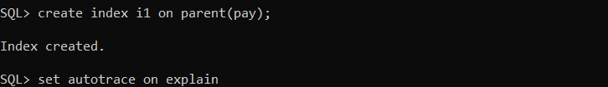 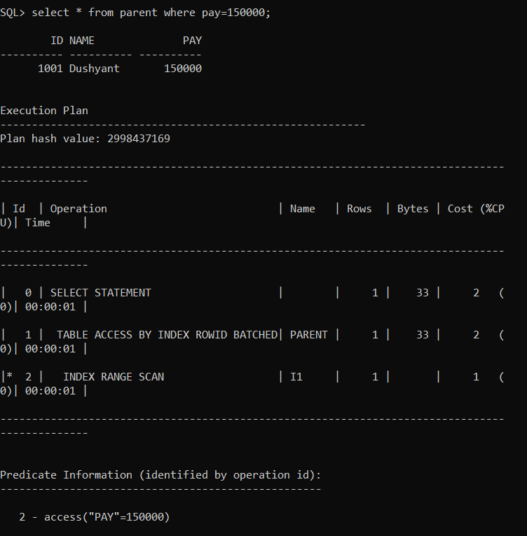

RESULT:

Thus, the integrity constraints commands have been executed successfully